TC Cockpit – Billing Participation Metrics Report
Part One Assembly 1.0
Deployment Guide

Revision History
Author | Revision Number | Date
flexme | 1.0 | 15th/Sep/2011

Deployment Instructions 3
1. Organization of Submission 3
2. Application Setup 3
2.1. Ant .Properties File 3
2.2. Build Scripts Setup 4
3. Database Setup 4
4. Deployment Instructions 5
5. Starting 5
6. Verification 5
7. Resource Contact List 7

Deployment Instructions

Organization of Submission
The included submission was organized as follows:

/
- Reviewer_Setup_Test_Instructions.README
VM and database setup and testing instructions for the reviewers.
docs/
- Deployment_Guide.doc
Deployment Guide for this submission

queries/
This directory contains SQL text for updated queries.

test_files/
This directory includes SQL scripts that are needed for testing and review. (This will only be valuable for reviewers)

direct/
This directory and subdirectories contain all modified and added source / static files of Direct.

database/
This directory contains the modified and added files for the database trunk in SVN.
https://coder.topcoder.com/internal/database/scripts/trunk

If you deploy the database locally, you can merge the files under this directory to the SVN directory and re-setup the database.

Application Setup

- The configuration file struts.xml has been changed in this submission.
- The configuration file applicationContext.xml has been changed in this submission.

Configuration file / property name | Comments
direct/conf/web/WEB-INF/applicationContext.xml | Add the spring injection configuration for new actions dashboardShowParticipationReportAction and dashboardParticipationReportAction
direct/conf/web/WEB-INF/struts.xml | Added actions dashboardParticipationReport and dashboardGetParticipationReport

Ant .Properties File
No changes were performed regarding Ant .Properties file.

Build Scripts Setup
The build script for Direct application (build.xml) provides the following targets which are to be used:

- switch-and-checkout –checkout or switch to the defined source code branches for all components defined in subprojects.xml
- dist-backend –rebuilt all the components from the source code.
- first_deploy –must be the first task to execute from command line. It will copy all dependencies to your local JBoss folder.
- deploy –should be the main task to execute from command line. It will build and deploy WAR file.
- deploy-apache-static – deploy the static files to Apache (Used in VM environment).
- deploy-static-files –deploys the static files to jboss (Used in Local environment).

You can get more information here:
http://www.topcoder.com/wiki/display/docs/TC+Direct+Setup+Guide

Database Setup

Two queries have been added in this assembly.

For locally deployment, please follow the instructions from TopCoder Databases Deployment Guide document from http://www.topcoder.com/wiki/display/docs/TopCoder+Databases+Setup+Guide
for setting up the database. Please copy the content from database directory to the database script directory.

For VM deployment, you can use Query Tool to update/add queries.

- Use Query Tool to add the following queries for database tcs_catalog.
Query Name | Query Content | Inputs
dashboard_participation_copilots | query/query_ dashboard_participation_copilots.txt | pcids  clientid  billingaccountid  tcdirectid  sdt  edt
dashboard_participation_contest_details | query/query_dashboard_participation_contest_details.txt | pcids  clientid  billingaccountid  tcdirectid  sdt  edt

- Use Query Tool to add a new command named dashboard_participation_report, and add the two queries (dashboard_participation_copilots and dashboard_participation_contest_details) to the command.

Deployment Instructions

This section provides the instructions in Production environment.

- Merge the code from submission into SVN branch for Direct application
- Build and deploy Direct application using ant deploy (or ant first_deploy ) command.
- Copy static files using ant deploy-static-files or ant deploy-apache-static command.

Note: VM deployment instructions for reviewers are in Reviewer_Setup_Test_Instructions.README document.

Starting

- Build and deploy the Direct application
- Start JBoss server instance hosting Direct application

Verification

- Run test_files/test_data.sql in database to insert some test data.
Login in VM as tc, execute
~/web/scripts/dwload/loadtcs.sh (ignore any error if any)

- Open http://localhost:8180/direct/ or http://cockpit.cloud.topcoder.com/direct/ , login as heffan/password.

- Click the “Report” tab on the top right. The following page will be displayed.
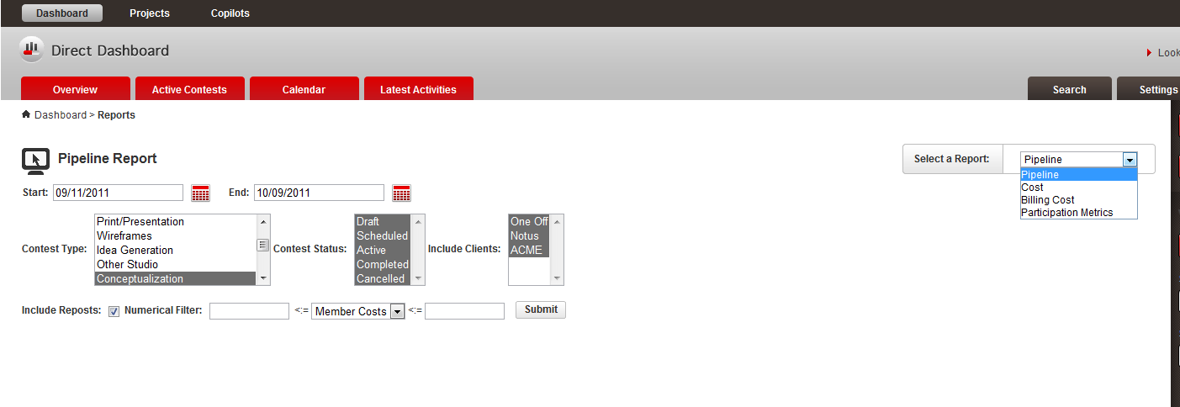

- You can choose “Participation Metrics” on the “Select a Report” drop down. The Participation Metrics report page will be displayed.
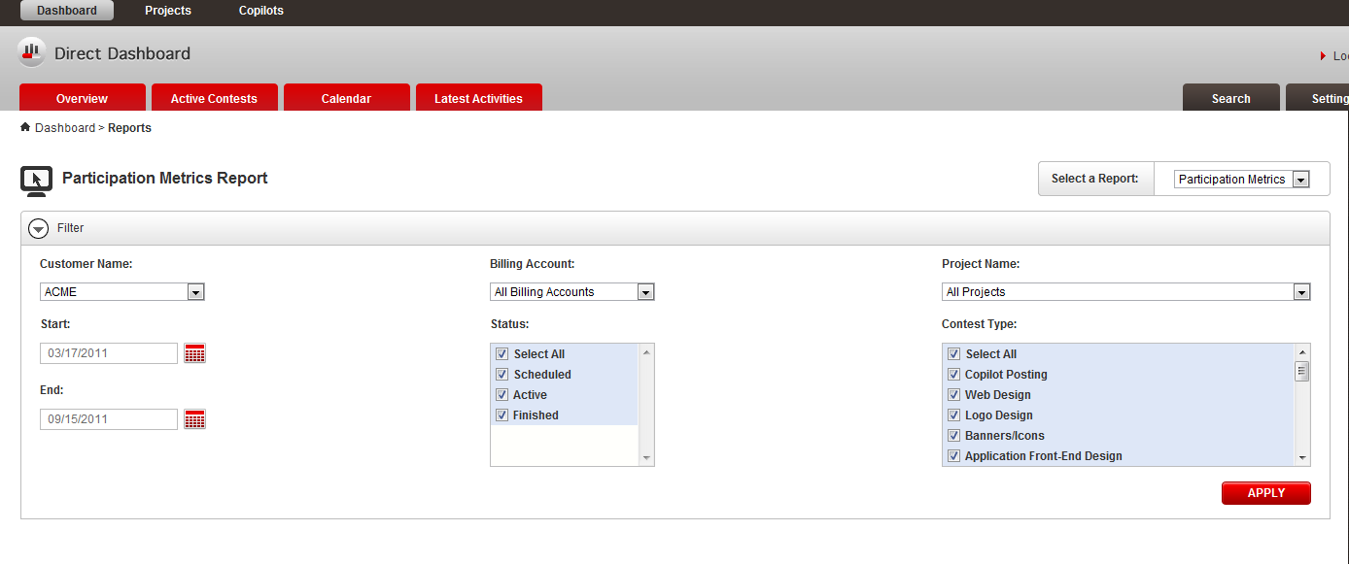

- The “Billing Account” and “Project Name” dropdowns will be dynamic changed when “Customer Name” has been changed. The “Project Name” dropdown will be dynamic changed when “Billing Account” has been changed.

- Click “Apply” button, the report data will be displayed.
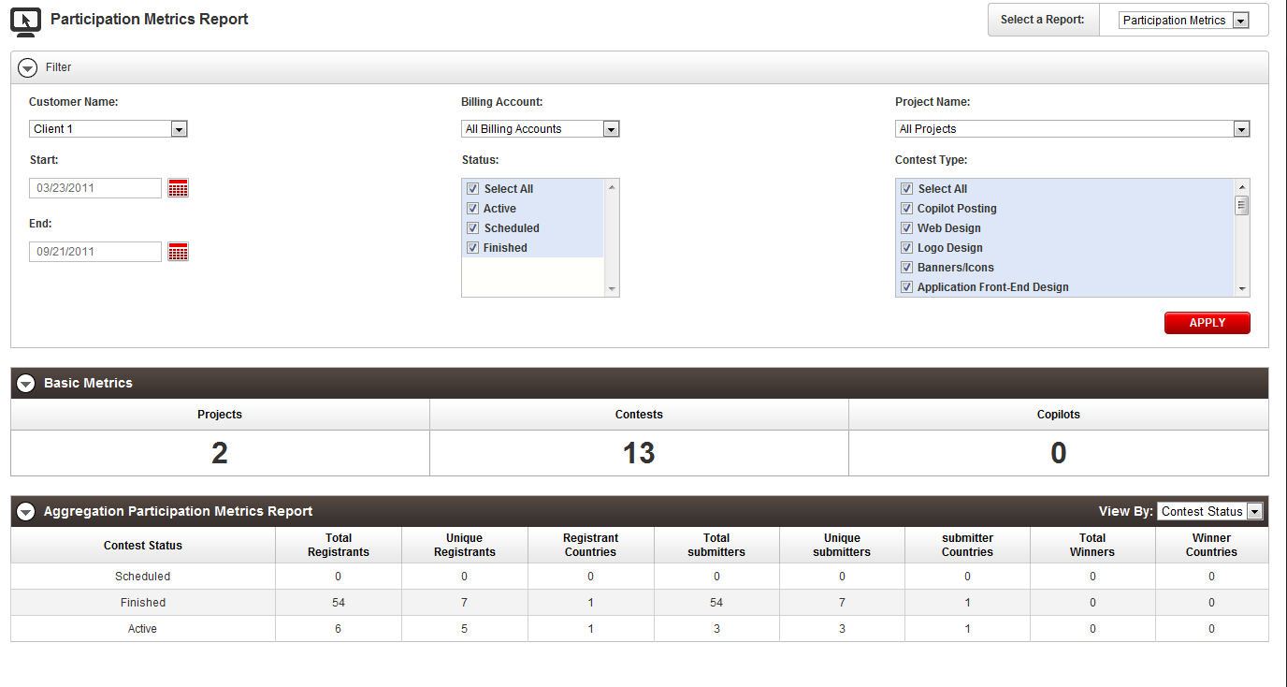

- In the “Aggregation Participation Metrics Report” section, you can change the aggregation type by change the “View By” dropdown box.

- If the “Start” date is after “End” data, error message will be displayed.

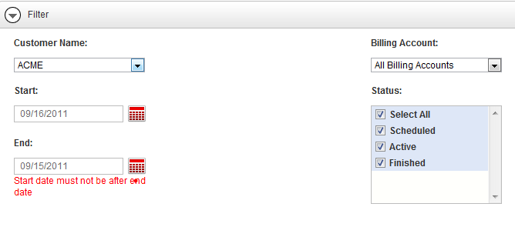

Resource Contact List

Name | Resource Email
flexme | cs.kunchen@gmail.com

